**Customer Relationship Management Assignment**

**Test Scenario 1:** The main page displays all customers present in the database having attributes:

a) First Name

b) Last Name

c) Email

Action Buttons (Update and Delete) are also provided.

**Test Scenario 2:** Add customer button is configured that redirects to a new page which consists of form to add the customer details:

1. Add Button is configured

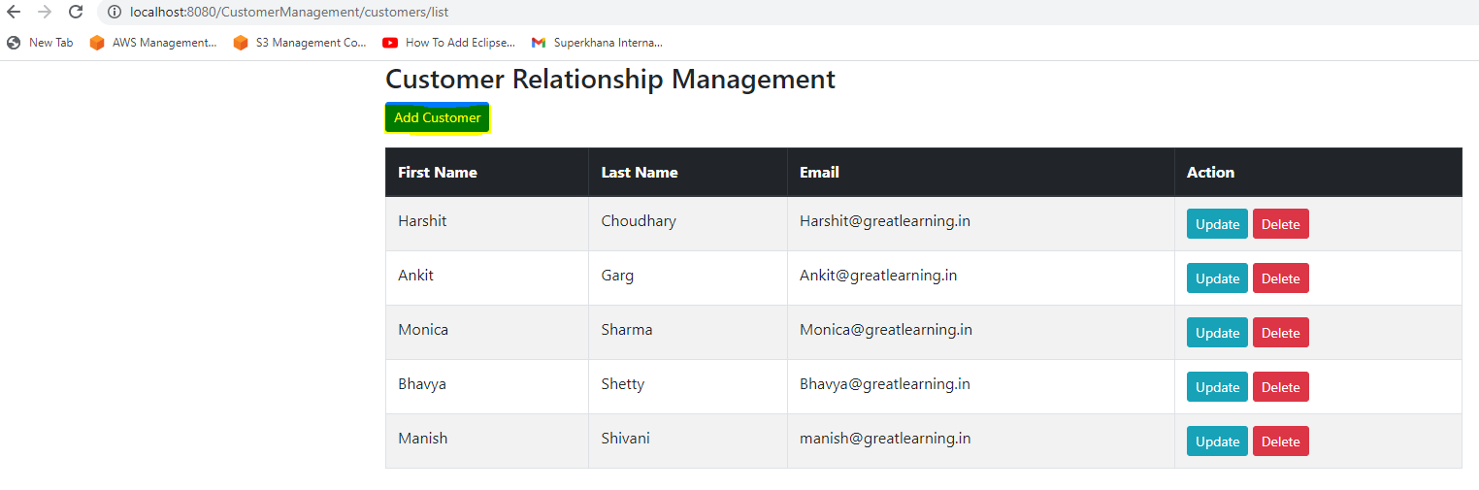

1. Click on “Add Customer” button redirects to a new page which consists of form to add the customer details:

1. Click Submit. New user is added to the table:

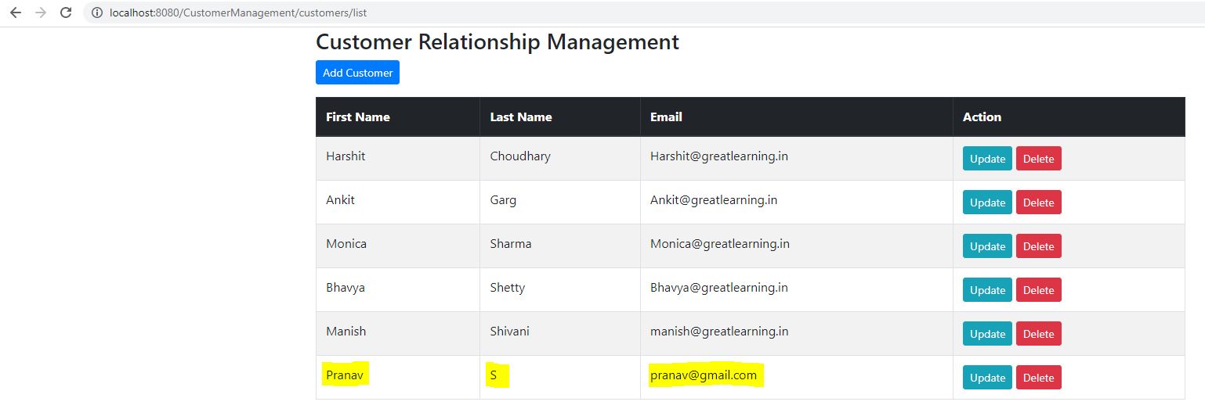

**Test Scenario 3:** Upon clicking the update button the user is redirected to a new page which will consist of the form same as save page with prepopulated data.

Updating the email address for customer “Harshit Choudhary” and save it with address @gmail.com

Updated value of Customer Harshit Choudhary with email address ending with gmail.com:

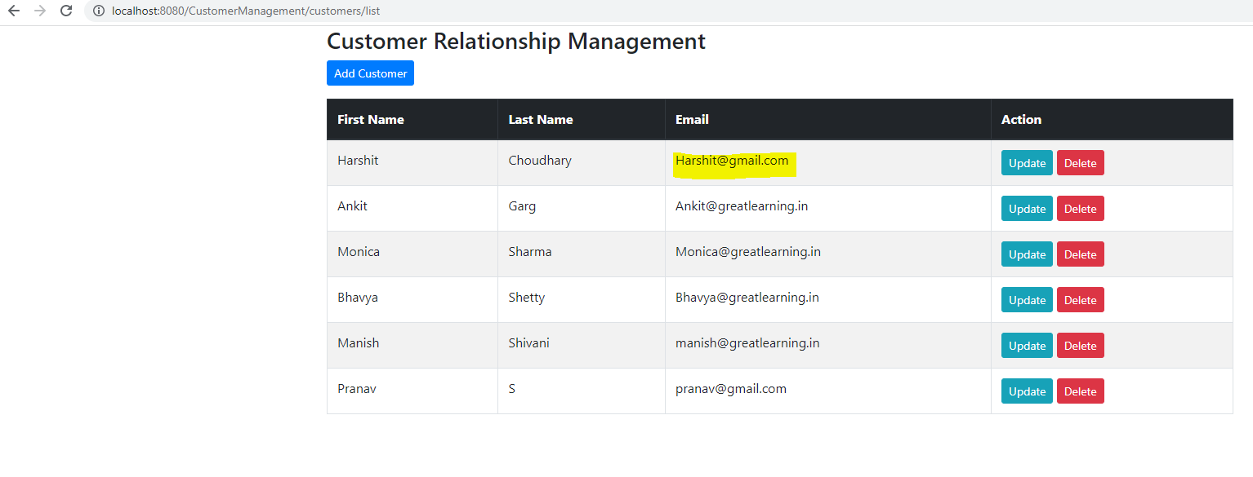

**Test Scenario 4:** Upon clicking the delete button, a pop up is generated

Upon clicking on the delete button for Customer “Harshit Choudhary”, the customer entry is deleted from the database

Updated list of employees upon deleting customer Harshit Choudhary:

